# **POWER BI ARC DIAGRAM TUTORIAL**

1. **Load sample data in power bi**

The sample data file is located in ***/pbiViz/arcSample.csv***. This is the general structure that is required for the Arc Diagram plug-in. The two sequence columns are used to determine the order of nodes. **They must match the names in the from and to columns.**

1. **Import arc diagram custom visual**

In Power Bi, under **VISUALIZATIONS**, click the ellipses symbol and select **Import****from file.**

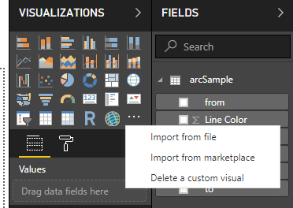

Navigate to ***\pbiViz\arcdiagram\dist***and select ***arcdiagram.pbiviz.*** If the import was successful, you should now see a new button in the Visualizations menu:

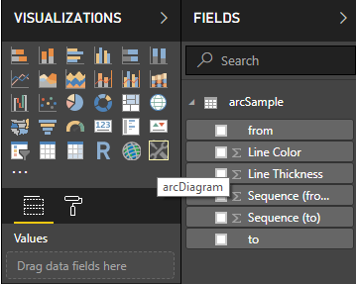

1. **Create arc diagram**

Select the arcDiagram visualization and if prompted to Enable script visuals, select Enable.

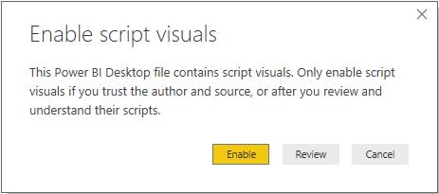

Resize the visualization to take up about half the width and height of the dashboard.

With the visualization selected, drag the values from the arcSample table in the following order:

**from > to > Line Thickness > Line Color > Sequence (from) > Sequence (to)**

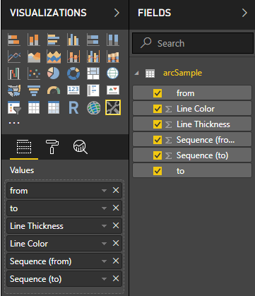

The default Arc Diagram should now appear:

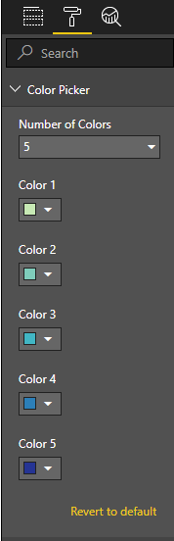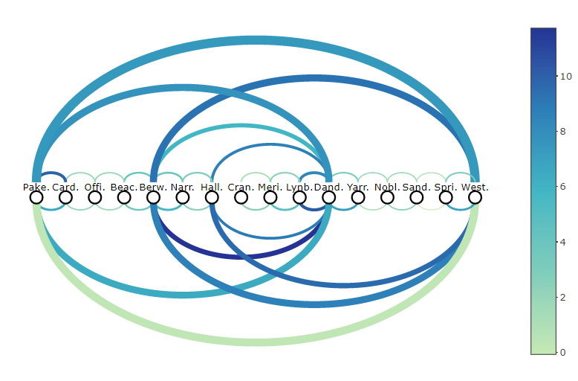

1. **Customise colors by using the Color Picker**

* Color 1 through 5 will modify the color scale from the lowest to the highest data point respectively
* Number of colors alters the color scale to only use the top *n* colors. (e.g. if number of colors = 3, then only Color 1, 2 and 3 are used)

**OPTIONAL: IMPORT CUSTOM THEME (Wes Anderson Color Palette)**

To import the Wes Anderson Color Palette, select **Switch Theme > Import Theme.**

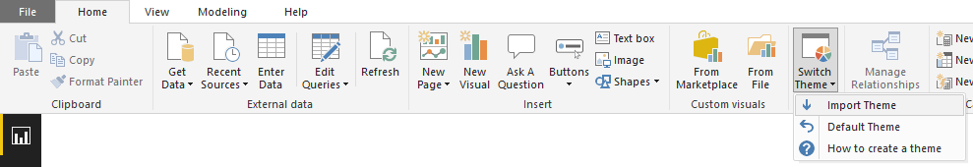

Then navigate to ***\pbiViz\themes*** and select ***WesAndersonColors.json***. The default colors should now have changed:

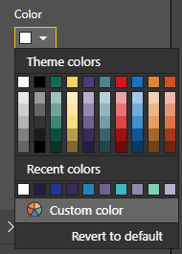

PowerBI only displays the first 8 colors in the theme file (plus black and white by default). To change the palette, simply edit the .json file and change the order of colors, then import again.